Task 1
- Task 1: Theory. Question done in iPynb and above.
- Unstructured Data.
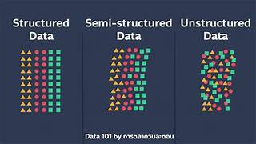

- Unstructured Data- Types.

- Primary Deficit vs Fiscal Deficit


- Indian Fiscal Deficit year 2020-2021

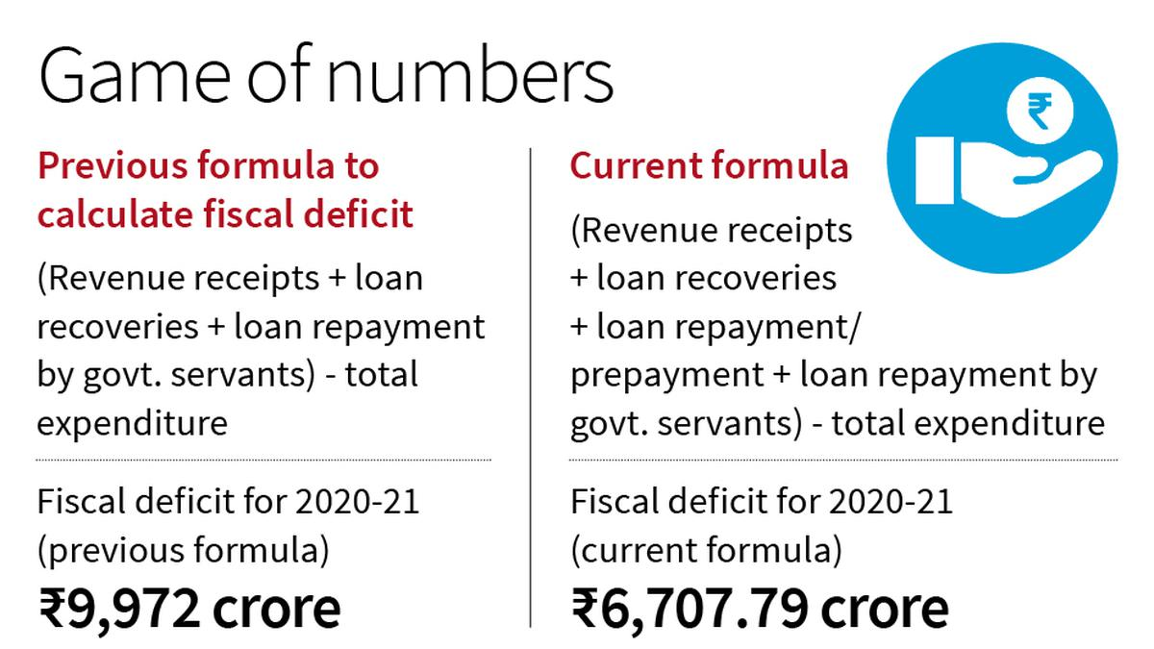

Task 2
a. Pick government securities from a country. The country selected was made to fit a Nelson-Siegel model.

b. Maturities were picked ranging from short-term to long-term ('1 Month', '3 Month', '6 Month', '1 Year', '2 Year', '3 Year', '5 Year', '7 Year', '10 Year', '20 Year', '30 Year’).
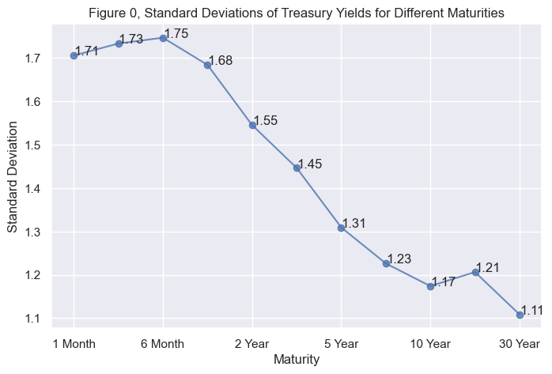

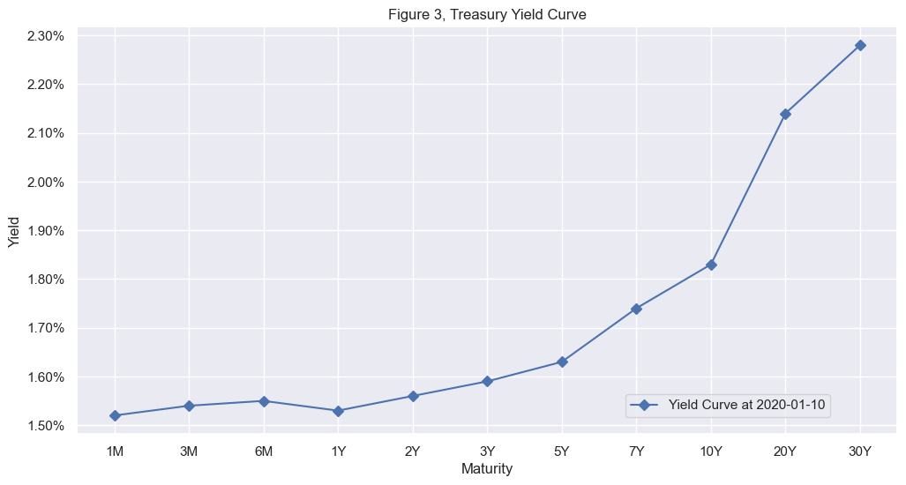
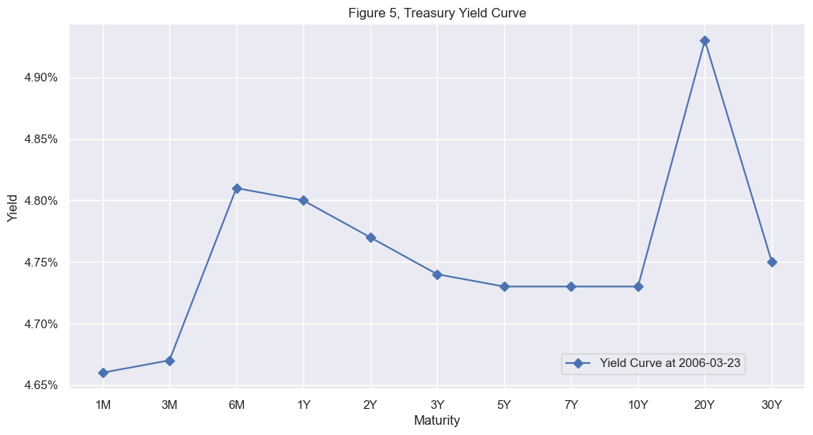

c. A Nelson-Siegel model was fitted to the data downloaded using the FRED API.
NelsonSiegelCurve(beta0=2.637680762823982, beta1=-1.1025858233847181, beta2=-1.14064731495874, tau=4.750015382763664)

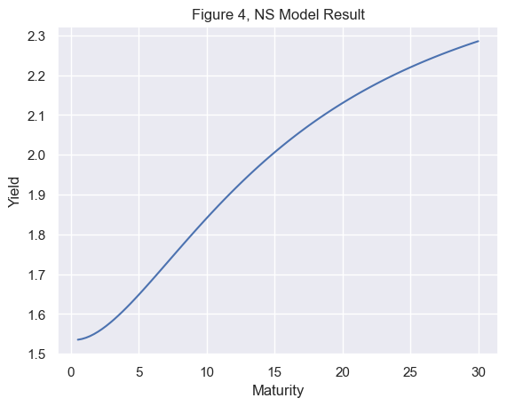
NelsonSiegelCurve(beta0=4.769301549476639, beta1=-0.186085699006459, beta2=0.2593711556488967, tau=0.2570488913193044)

d. A Cubic-Spline model was fitted to the downloaded data uing the FRED API.
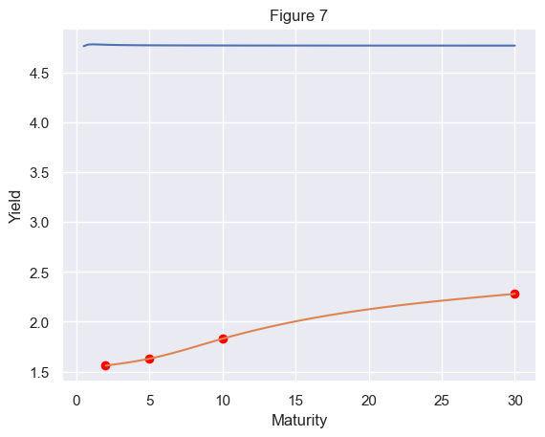

e. The models were compared in terms of 1) fit and 2) interpretation.
The Nelson-Siegel model provides a parsimonious representation of the yield curve using only four parameters. It aims to capture the overall level, slope, and curvature. The fit appears [Observe the plot and describe the fit - e.g., reasonable, good, not perfect], suggesting it captures the general shape of the yield curve. The parameters have economic interpretations: Beta0 represents the long-term yield, Beta1 the short-term spread, Beta2 the curvature, and Lambda controls the decay rate of the short and medium-term components.

The Cubic Spline model, on the other hand, is a non-parametric method that fits a piecewise cubic polynomial to the data points. It is very flexible and can fit the observed yields almost perfectly, as seen in the plot. However, the interpretation of the resulting spline function is less straightforward than the Nelson-Siegel parameters. While it provides a smooth curve that passes through the data points, the coefficients of the cubic polynomials in each segment do not have direct economic meaning in the same way as the Nelson-Siegel parameters.

In terms of fit, the Cubic Spline likely has a lower error (if calculated) because of its flexibility. However, the Nelson-Siegel model offers a more interpretable and potentially more robust representation if the goal is to understand the underlying factors shaping the yield curve.

f. The levels of model parameters:
The estimated Nelson-Siegel model parameters are:
- Beta0 (Long-term level)
- Beta1 (Short-term factor)
- Beta2 (Medium-term factor)
- Lambda (Decay factor)

[1.56000005 1.56560021 1.57125413 1.57701558 1.58293833 1.58907612
1.59548274 1.60221193 1.60931746 1.6168531 1.62487261 1.6334279
1.64253281 1.65214533 1.66222046 1.67271323 1.68357863 1.6947717
1.70624743 1.71796086 1.72986698 1.74192083 1.7540774 1.76629172
1.7785188 1.79071365 1.8028313 1.81482674 1.82665501 1.83827551
1.84967209 1.86084912 1.87180977 1.88255723 1.89309467 1.90342528
1.91355223 1.92347873 1.93320793 1.94274303 1.95208721 1.96124364
1.97021552 1.97900602 1.98761832 1.99605561 2.00432107 2.01241788
2.02034922 2.02811828 2.03572823 2.04318225 2.05048354 2.05763527
2.06464062 2.07150277 2.07822491 2.08481022 2.09126189 2.09758308
2.10377698 2.10984679 2.11579567 2.1216268 2.12734338 2.13294859
2.1384456 2.14383759 2.14912775 2.15431927 2.15941531 2.16441907
2.16933373 2.17416246 2.17890846 2.18357489 2.18816495 2.19268181
2.19712866 2.20150868 2.20582505 2.21008095 2.21427957 2.21842408
2.22251767 2.22656352 2.23056481 2.23452472 2.23844644 2.24233315
2.24618802 2.25001425 2.25381501 2.25759348 2.26135285 2.26509629
2.268827 2.27254815 2.27626292 2.2799745 ]

The Cubic Spline model is defined by a series of piecewise cubic polynomial functions that smoothly connect the given maturity-yield data points. The model's parameters are implicitly defined by the yields at the chosen maturities, and the resulting spline ensures continuity of the function and its first two derivatives at the knots (the given maturities).

g. Module 2 Lesson 4 (‘Smoothing Data’), smoothing data can be unethical.
Whether smoothing the yield curve using the Nelson-Siegel model is considered unethical is debatable and depends on the intent and context. If the goal is to obtain a parsimonious and interpretable representation of the underlying yield curve, to filter out noise or temporary market fluctuations, and to understand the general shape and expected future rates, then it is generally not considered unethical. The model provides a simplified view based on a theoretical framework.
However, if the smoothing is done with the intention to misrepresent the actual market prices, to hide important information, or to create an artificial yield curve for manipulative purposes (e.g., in valuation or trading strategies without acknowledging the model's limitations), then it could be considered unethical. Transparency about the model used, its limitations, and the reasons for smoothing are crucial for ethical data analysis. In the case of Nelson-Siegel, it's a well-established model used for analysis and understanding, and its application is usually for insight rather than direct manipulation of market prices.

Task 3
- 5 uncorrelated Gaussian random variables were generated that simulate yield changes (they can be positive or negative with a mean close to 0 and a standard deviation that is small).
np.random.seed(42)
num_observations = 250 # Adjust as needed
uncorrelated_data = np.random.randn(num_observations, 5)
df_uncorrelated = pd.DataFrame(uncorrelated_data, columns=['Var1', 'Var2', 'Var3', 'Var4', 'Var5'])
b. Ran a Principal Components Analysis using EITHER the correlation and the corelation matrix.
c. A paragraph was written explaining how the variances of each component compare with each other.Variance was explained as by Component 1, Component 2, …. and Component 5.
Paragrapgh: For uncorrelated Gaussian random variables, each principal component captures roughly an equal proportion of the total variance. With 5 variables, we expect each component to explain approximately 1/5 or 20% of the variance. The printed explained variance ratios should reflect this, with values close to 0.2 for each component.

d. A screenplot was produced and the variance was explained for each component.

Explained Variance Ratio (Uncorrelated Data): [0.23216471 0.21685579 0.19669008 0.180105 0.17418442]
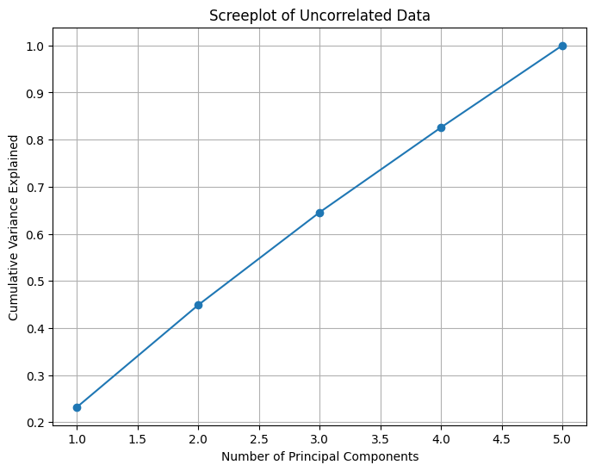

Working with real data:
e. Collect the daily closing yields for 5 government securities, say over 6 months.
As mentioned before, Yahoo Finance might not have comprehensive historical yield data for Indian Government Bonds. You might need to find an alternative data source and load it here.
The following is a placeholder assuming you have a way to get this data into a pandas DataFrame. For demonstration, we created some synthetic correlated yield data

np.random.seed(43)
num_days = 250
yields_real = pd.DataFrame({
'Yield1': np.cumsum(0.001 + 0.0005 * np.random.randn(num_days)),
'Yield2': np.cumsum(0.0012 + 0.0006 * np.random.randn(num_days)),
'Yield3': np.cumsum(0.0015 + 0.0007 * np.random.randn(num_days)),
'Yield4': np.cumsum(0.0018 + 0.0008 * np.random.randn(num_days)),
'Yield5': np.cumsum(0.0020 + 0.0009 * np.random.randn(num_days)),
}, index=pd.to_datetime(pd.date_range(start='2024-01-01', periods=num_days)))

f. Be sure to compute the daily yield changes!
g. Re-run the Principal Components using EITHER the correlation or covariance matrix.
h. The variances of each component compared. Variance was explained by how much Component 1, Component 2, ….. and Component 5 were produced.

Explained Variance Ratio (Real Yield Changes): [0.22960394 0.22091755 0.20368223 0.1811117 0.16468458]

For real government bond yield changes, we typically observe that the first few principal components explain a significant majority of the total variance. This indicates strong correlations in how yields of different maturities move. The first component often represents a parallel shift in the yield curve (level), the second a change in the slope, and so on. The printed explained variance ratios should show a much higher value for the first component(s) compared to the uncorrelated data.
i. A screenplot was produced and the variance was explained for each component.
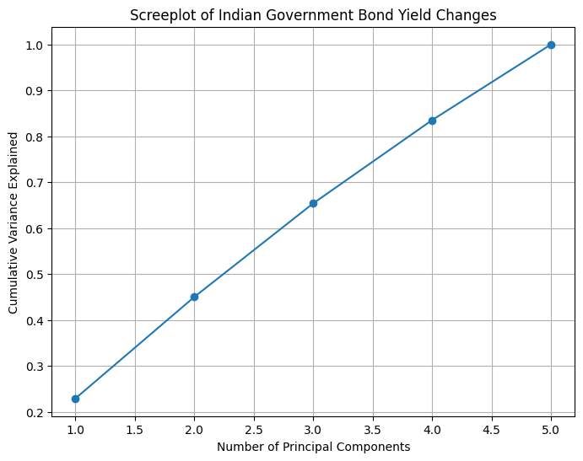

j. The uncorrelated data screenplot was compared with the screenplot from the government data.
The screenplot for the uncorrelated data shows a gradual increase in cumulative variance explained, with each component contributing roughly equally. In contrast, the screenplot for the government bond yield changes shows a much steeper initial increase, meaning the first few principal components explain a large fraction of the total variance. This significant difference highlights the presence of strong correlations among the changes in government bond yields, which is absent in the uncorrelated random data. The "elbow" in the real data screenplot suggests that a lower number of principal components can effectively capture most of the variability in yield changes.

Task 4

4. a. Find the 30 Largest Holdings
You would typically find this information on the ETF provider's website (e.g., State Street Global Advisors for SPDR ETFs). For XLRE, you can search online for its top holdings as of a recent date.

**Replace the list below with the actual top 30 tickers.**

top_30_tickers = [
"PLD", "AMT", "PSA", "EQIX", "SPG", "O", "ARE", "AVB", "EQR", "DLR",
"CCI", "WELL", "VTR", "BXP", "SLG", "KIM", "FRT", "PEAK", "UDR", "EXR",
"IRM", "CPT", "REG", "WPC", "NLY", "AGNC", "MAA", "ESS", "INVH", "RWR"
]

4. b. 6 months of data was fetched.

Download stock prices from Yahoo Finance and set the time period for download
start = datetime.date(2018, 1, 2)
end = datetime.date(2018, 6, 2)
stocks = yfin.download(["AAPL", "F", "WMT","PFE"], start, end, auto_adjust = False)["Adj Close"]
stocks.head()

4. c. Daily Returns were computed.
Ticker | AAPL | F | WMT | PFE
Date
2018-01-03 | -0.000174 | 0.007899 | 0.008723 | 0.007409
2018-01-04 | 0.004645 | 0.017242 | 0.000905 | 0.002179
2018-01-05 | 0.011386 | 0.016949 | 0.005927 | 0.001902
2018-01-08 | -0.003714 | -0.003788 | 0.014781 | -0.011123
2018-01-09 | -0.000114 | -0.005323 | -0.012007 | -0.001097

4. d. Covariance matrix was computed
Squared Singular values (eigenvalues):
[1.8947491 0.83555338 0.71064906 0.55904846]

Matrix V (eigenvectors)
[[ 0.56634753 0.14011675 -0.2163749 -0.78281522]
[ 0.4596476 0.75759295 0.01833686 0.46307749]
[ 0.48586789 -0.53226677 -0.55857234 0.41063538]
[ 0.48156718 -0.35087363 0.80052645 0.06432843]]

4. e. array([1.8947491 , 0.83555338, 0.71064906, 0.55904846])
eigenvectors
array([[-0.56634753, 0.14011675, -0.2163749 , -0.78281522],
[-0.4596476 , 0.75759295, 0.01833686, 0.46307749],
[-0.48586789, -0.53226677, -0.55857234, 0.41063538],
[-0.48156718, -0.35087363, 0.80052645, 0.06432843]])

4. f. PCA and SVD were compared.

Ticker | AAPL | F | WMT | PFE
Date
2018-01-03 | -0.070347 | 0.286262 | 0.584137 | 0.446787
2018-01-04 | 0.171130 | 0.647650 | 0.030003 | 0.124454
2018-01-05 | 0.508941 | 0.636329 | 0.385979 | 0.107385
2018-01-08 | -0.247764 | -0.165775 | 1.013509 | -0.695394
2018-01-09 | -0.067364 | -0.225157 | -0.885168 | -0.077492

